## **Directories in Python**

All files are contained within various directories, and Python has no problem handling these too. The **os** module has several methods that help you create, remove, and change directories.

## **The *mkdir()* Method**

You can use the *mkdir()* method of the **os** module to create directories in the current directory. You need to supply an argument to this method which contains the name of the directory to be created.

### **Syntax**

os.mkdir("newdir")

### **Example**

Following is the example to create a directory *test* in the current directory −

import os  
# Create a directory "test"  
os.mkdir("test")

Creating NEw Sub folder in d:\myfold

## 

## 

## **Create File in Subfolders**

Creating NEW file in d:\\myfold\\mysubfold with name ‘hello.txt’ file

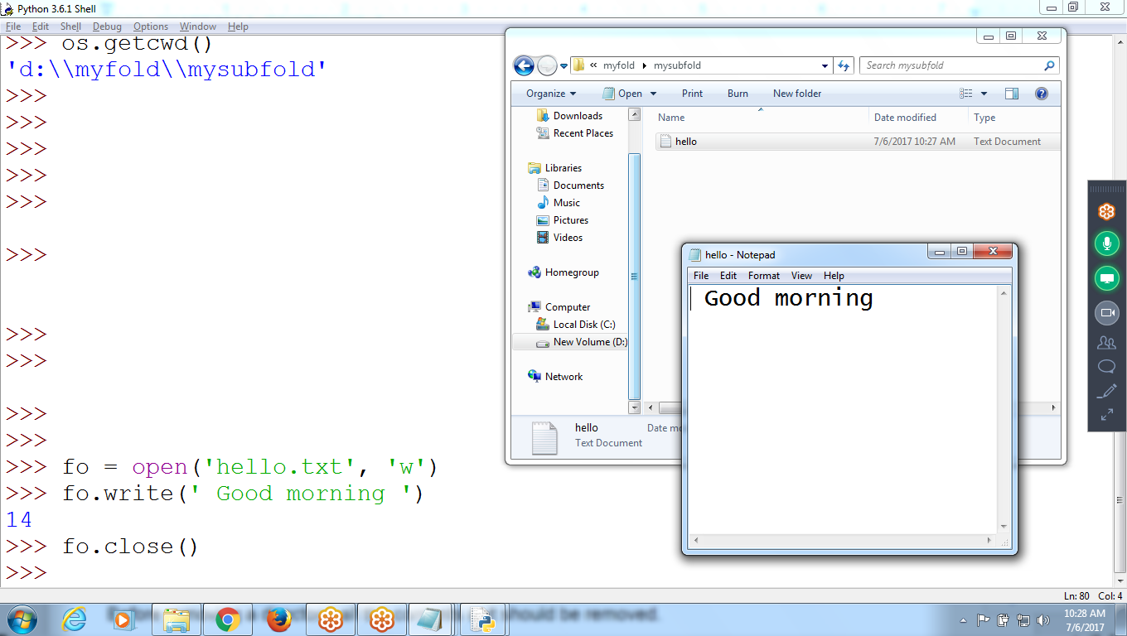

## 

## 

## 

## **The *rmdir()* Method**

The *rmdir()* method deletes the directory, which is passed as an argument in the method.

Before removing a directory, all the contents in it should be removed.

### **Syntax:**

os.rmdir('dirname')

### **Example**

Following is the example to remove "/tmp/test" directory. It is required to give fully qualified name of the directory, otherwise it would search for that directory in the current directory.

import os  
# This would remove "/tmp/test" directory.  
os.rmdir( "/tmp/test" )

>>> os.getcwd()

'D:\\myfold\\mysubfold'

**>>> os.rmdir('mysubfold') # Being same folder can not remove**

Traceback (most recent call last):

File "<pyshell#64>", line 1, in <module>

os.rmdir('mysubfold')

FileNotFoundError: [WinError 2] **The system cannot find the file specified: 'mysubfold'**

>>>

>>>

>>>

>>>

>>>

>>>

**>>> os.chdir('../')**  **# Changing directory to Parent**

>>> os.getcwd()

'D:\\myfold'

>>> os.rmdir('mysubfold')

Traceback (most recent call last):

File "<pyshell#73>", line 1, in <module>

os.rmdir('mysubfold')

PermissionError: [WinError 32] **The process cannot access the file because it is being used by another** process: 'mysubfold'

**>>> os.rmdir('mysubfold')** **# TO Delete FOlder, first need to Delete files in the folder**

Traceback (most recent call last):

File "<pyshell#74>", line 1, in <module>

os.rmdir('mysubfold')

OSError: [WinError 145] **The directory is not empty: 'mysubfold'**

>>>

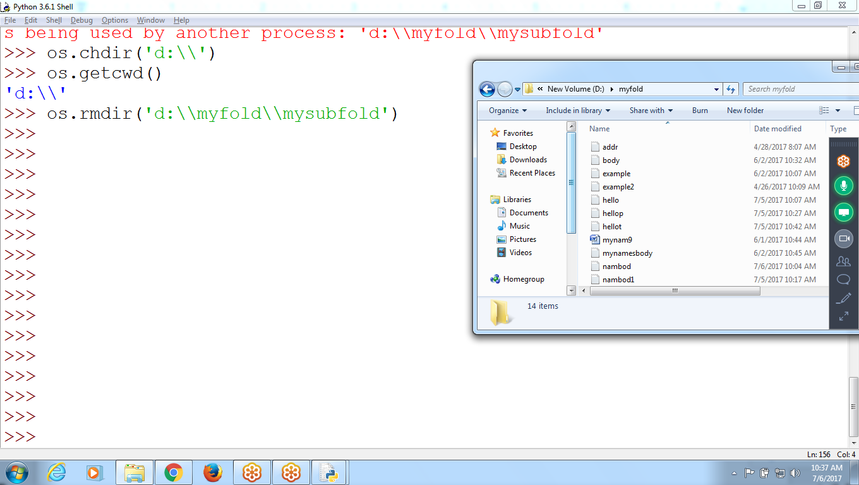

## **The Current Working Directory**

To get the current working directory as a string value with the os.getcwd() function and

change it with os.chdir()

>>> import os

>>> os.getcwd()

'C:\\Python34'

>>> **os.chdir** ('c:\\windows\\system32')

>>> os.getcwd()

'c:\\windows\\system32'

>>>



 



